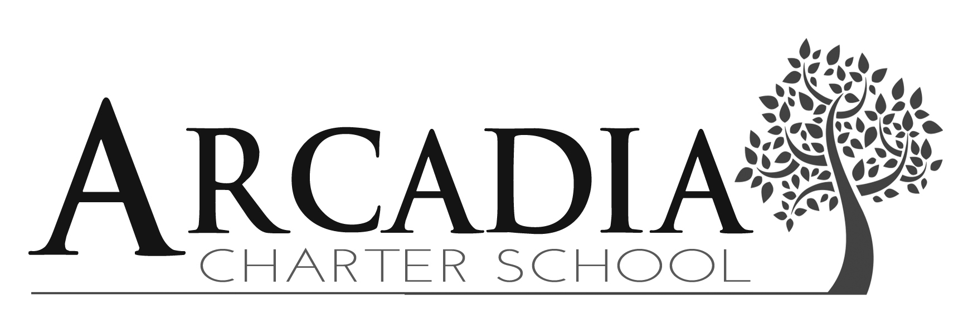
1719 Cannon Road, Northfield MN 55057 (507) 663-8806

The Special Education Advisory Council (SEAC) is made up of parents and professionals who are interested in promoting parent involvement at Arcadia Charter School.
We believe that one of the most important aspects of special education is the role played by parents in the education of their children with special needs. Parents are critical participants in ensuring the long-term success of their children, as Arcadia Charter School seeks ways in which
to best meet the needs of our special education students.

The purpose of SEAC is to create a forum for administrators, teachers and parents of students receiving special education services to come together for the continuous
improvement of Arcadia’s special education services through collective planning and parent education.
SEAC will…

- Work collaboratively to improve educational outcomes for students with disabilities.

- Advocate for children with disabilities and, on behalf of those children, for parents of children with disabilities.
- Provide a forum for parents to share ideas and information.

- Provide information about programs in the community to further support the needs of families of children with disabilities.

- Provide educational opportunities for parents to learn about additional ways to support their child.
SEAC will meet two times per year. This year’s meeting dates:
September 25, 2018
April 18, 2019
For more information please contact:

Lisa Malecha, Special Education Coordinator/School Social Worker
lmalecha@arcadiacharterschool.org
Cindy Graff, Special Education Administrative Assistant
cgraff@arcadiacharterschool.org

August 2015

